ARYAMAN MISHRA

19BCE1027

1) <!doctype html>

<html>

<head>

<meta charset="utf-8">

<title>Untitled Document</title>

<style>

body {

font-family: Roboto;

background: #456789;

background: -webkit-linear-gradient(to left, #8E0E00, #1F1C18);

background: linear-gradient(to left, #8E0E00, #1F1C18);

}

#container {

height: 525px;

width: 360px;

margin: 100px auto;

background: #f7f7f7;

box-shadow: 0 0 3px rgba(0, 0, 0, 0.1);

border-radius: 20px;

-webkit-border-radius: 20px;

-moz-border-radius: 20px;

}

h1 {

background:#565656;;

color: white;

margin: 0;

padding: 10px 100px;

text-transform:lowercase;

font-size: 18px;

font-weight: normal;

border-top-left-radius: 20px;

border-top-right-radius: 20px;

}

p {

padding-left: 20px;

}

form input[type="text"] {

width=90px;

}

input {

padding-left: 20px;

}

#billamt {

font-size: 14px;

color: #red;

background-color:#FFFFFF;

width: 60%;

padding: 5px 5px 8px 8px;

}

#billamt:focus {

background: #fff;

border: 3px solid #2980b9;

outline: none;

}

#peopleamt {

width: 60%;

padding: 5px 5px 8px 8px;

margin-left: 20px;

color: #red;

background-color: #f7f7f7;

font-size: 14px;

}

.dollarSign {

display: inline;

}

#serviceQual {

padding: 13px 13px 20px 20px;

margin-left: 20px;

font-size: 25px;

}

button {

text-transform: uppercase;

font-weight: bold;

display: block;

margin: 30px auto;

background: #AD133A;

border-radius: 5px;

width: 200px;

height: 50px;

font-size: 17px;

color: white;

}

button:hover {

background: #4c2827;

border-bottom-color: #111;

}

button:active {

position: relative;

top: 1px;

}

#totalTip {

font-size: 30px;

margin-top: 5px;

text-align: center;

}

#totalTip:before {

content: "Tip amount";

font-size: 20px;

font-weight: bold;

display: block;

text-transform: uppercase;

}

#totalTip sup {

font-size: 20px;

top: -18px;

}

#totalTip small {

font-size: 20px;

font-weight: bold;

display: block;

}

</style>

</head>

<body background="restaurant-interior_1127-3394">

<div id="container">

<h1>Tip Calculator</h1>

<div id="calculator">

<form>

<p>How much was your bill?</p>

<p>&#x20b9;<input id="billamt" type="text" placeholder="Bill Amount"></p>

<p>How was your service?</p>

<p>

<select id="serviceQual">

<option disabled selected value="0">-- Choose an Option --</option>

<option value="0.3">30&#37; &#45; Outstanding</option>

<option value="0.2">20&#37; &#45; Good</option>

<option value="0.15">15&#37; &#45; It was OK</option>

<option value="0.1">10&#37; &#45; Bad</option>

<option value="0.05">5&#37; &#45; Terrible</option>

</select>

</p>

</form>

<p>How many people are sharing the bill?</p>

<input id="peopleamt" type="text" placeholder="Number of People"> people

<button type="button" id="calculate">Calculate!</button>

</div>

<!--calculator end-->

<div id="totalTip">

<sup>&#x20b9</sup><span id="tip">0.00</span>

<small id="each">each</small>

</div>

</div>

<script>

function calculateTip() {

var billAmt = document.getElementById("billamt").value;

var serviceQual = document.getElementById("serviceQual").value;

var numOfPeople = document.getElementById("peopleamt").value;

if (billAmt === "" || serviceQual == 0) {

alert("Please enter values");

return;

}

if (numOfPeople === "" || numOfPeople <= 1) {

numOfPeople = 1;

document.getElementById("each").style.display = "none";

} else {

document.getElementById("each").style.display = "block";

}

var total = (billAmt * serviceQual) / numOfPeople;

total = Math.round(total * 100) / 100;

total = total.toFixed(2);

document.getElementById("totalTip").style.display = "block";

document.getElementById("tip").innerHTML = total;

}

document.getElementById("totalTip").style.display = "none";

document.getElementById("each").style.display = "none";

document.getElementById("calculate").onclick = function() {

calculateTip();

};

</script>

</body>

</html>

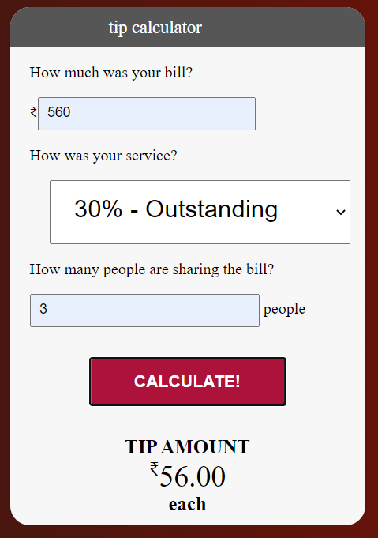

2) <!DOCTYPE html>

<html lang="en">

<head>

<meta charset="utf-8">

<title>JavaScript Form Validation using a sample registration form</title>

<style>

h1 {

margin-left: 70px;

}

form li {

list-style: none;

margin-bottom: 5px;

}

form ul li label{

float: left;

clear: left;

width: 100px;

text-align: right;

margin-right: 10px;

font-family:Verdana, Arial, Helvetica, sans-serif;

font-size:14px;

}

form ul li input, select, span {

float: left;

margin-bottom: 10px;

}

form textarea {

float: left;

width: 350px;

height: 150px;

}

[type="submit"] {

clear: left;

margin: 20px 0 0 230px;

font-size:18px

}

p {

margin-left: 70px;

font-weight: bold;

}

</style>

<script>

function formValidation()

{

var uid = document.registration.userid;

var passid = document.registration.passid;

var uname = document.registration.username;

var uadd = document.registration.address;

var ucountry = document.registration.country;

var uzip = document.registration.zip;

var uemail = document.registration.email;

var umsex = document.registration.msex;

var ufsex = document.registration.fsex;

var mobile=document.registration.mob;

if(userid_validation(uid,5,12))

{

if(passid_validation(passid,7,12))

{

if(allLetter(uname))

{

if(alphanumeric(uadd))

{

if(countryselect(ucountry))

{

if(allnumeric(uzip))

{

if(mobilenumber(mobile))

{

if(ValidateEmail(uemail))

{

if(validsex(umsex,ufsex))

{

}

}

}

}

}

}

}

}

}

return false;

}

function userid_validation(uid,mx,my)

{

var uid_len = uid.value.length;

if (uid_len == 0 || uid_len >= my || uid_len < mx)

{

alert("User Id should not be empty / length be between "+mx+" to "+my);

uid.focus();

return false;

}

return true;

}

function passid_validation(passid,mx,my)

{

var passid_len = passid.value.length;

if (passid_len == 0 ||passid_len >= my || passid_len < mx)

{

alert("Password should not be empty / length be between "+mx+" to "+my);

passid.focus();

return false;

}

return true;

}

function allLetter(uname)

{

var letters = /^[A-Za-z]+$/;

if(uname.value.match(letters))

{

return true;

}

else

{

alert('Username must have alphabet characters only');

uname.focus();

return false;

}

}

function alphanumeric(uadd)

{

var letters = /^[0-9a-zA-Z]+$/;

if(uadd.value.match(letters))

{

return true;

}

else

{

alert('User address must have alphanumeric characters only');

uadd.focus();

return false;

}

}

function countryselect(ucountry)

{

if(ucountry.value == "Default")

{

alert('Select your country from the list');

ucountry.focus();

return false;

}

else

{

return true;

}

}

function allnumeric(uzip)

{

var numbers = /^[0-9]+$/;

if(uzip.value.match(numbers))

{

return true;

}

else

{

alert('ZIP code must have numeric characters only');

uzip.focus();

return false;

}

}

function mobilenumber(mobile)

{

var numbers =/^((\+){1}91){1}[1-9]{1}[0-9]{9}$/;

if(mobile.value.match(numbers))

{

return true;

}

else

{

alert('Mobile Number must have numeric characters only');

mobile.focus();

return false;

}

}

function ValidateEmail(uemail)

{

var mailformat = /^\w+([\.-]?\w+)*@\w+([\.-]?\w+)*(\.\w{2,3})+$/;

if(uemail.value.match(mailformat))

{

return true;

}

else

{

alert("You have entered an invalid email address!");

uemail.focus();

return false;

}

}

function validsex(umsex,ufsex)

{

x=0;

if(umsex.checked)

{

x++;

} if(ufsex.checked)

{

x++;

}

if(x==0)

{

alert('Select Male/Female');

umsex.focus();

return false;

}

else

{

alert('Form Successfully Submitted');

window.location.reload()

return true;}

}

</script>

</head>

<body onload="document.registration.userid.focus();" background="sticker-png-life-insurance-claria-life-and-health-insurance-company-claria-internacional-rate-miscellaneous-blue-company-computer-wallpaper.png">

<h1>Registration Form</h1>

<form name="registration" onSubmit="return formValidation();">

<ul>

<li><label for="userid">User id:</label></li>

<li><input type="text" name="userid" size="12" /></li>

<li><label for="passid">Password:</label></li>

<li><input type="password" name="passid" size="12" /></li>

<li><label for="username">Name:</label></li>

<li><input type="text" name="username" size="50" /></li>

<li><label for="address">Address:</label></li>

<li><input type="text" name="address" size="50" /></li>

<li><label for="country">Country:</label></li>

<li><select name="country">

<option selected="" value="Default">(Please select a country)</option>

<option value="AF">Australia</option>

<option value="AL">Canada</option>

<option value="DZ">India</option>

<option value="AS">Russia</option>

<option value="AD">USA</option>

</select></li>

<li><label for="zip">ZIP Code:</label></li>

<li><input type="text" name="zip" /></li>

<li><label for="mob">Mobile Number:</label></li>

<li><input type="text" name="mob" /></li>

<li><label for="email">Email:</label></li>

<li><input type="text" name="email" size="50" /></li>

<li><label id="gender">Sex:</label></li>

<li><input type="radio" name="msex" value="Male" /><span>Male</span></li>

<li><input type="radio" name="fsex" value="Female" /><span>Female</span></li>

<li><label>Language:</label></li>

<li><input type="checkbox" name="en" value="en" checked /><span>English</span></li>

<li><input type="checkbox" name="nonen" value="noen" /><span>Non English</span></li>

<li><label for="desc">About:</label></li>

<li><textarea name="desc" id="desc"></textarea></li>

<li><input type="submit" name="submit" value="Submit" /></li>

</ul>

</form>

</body>

</html>

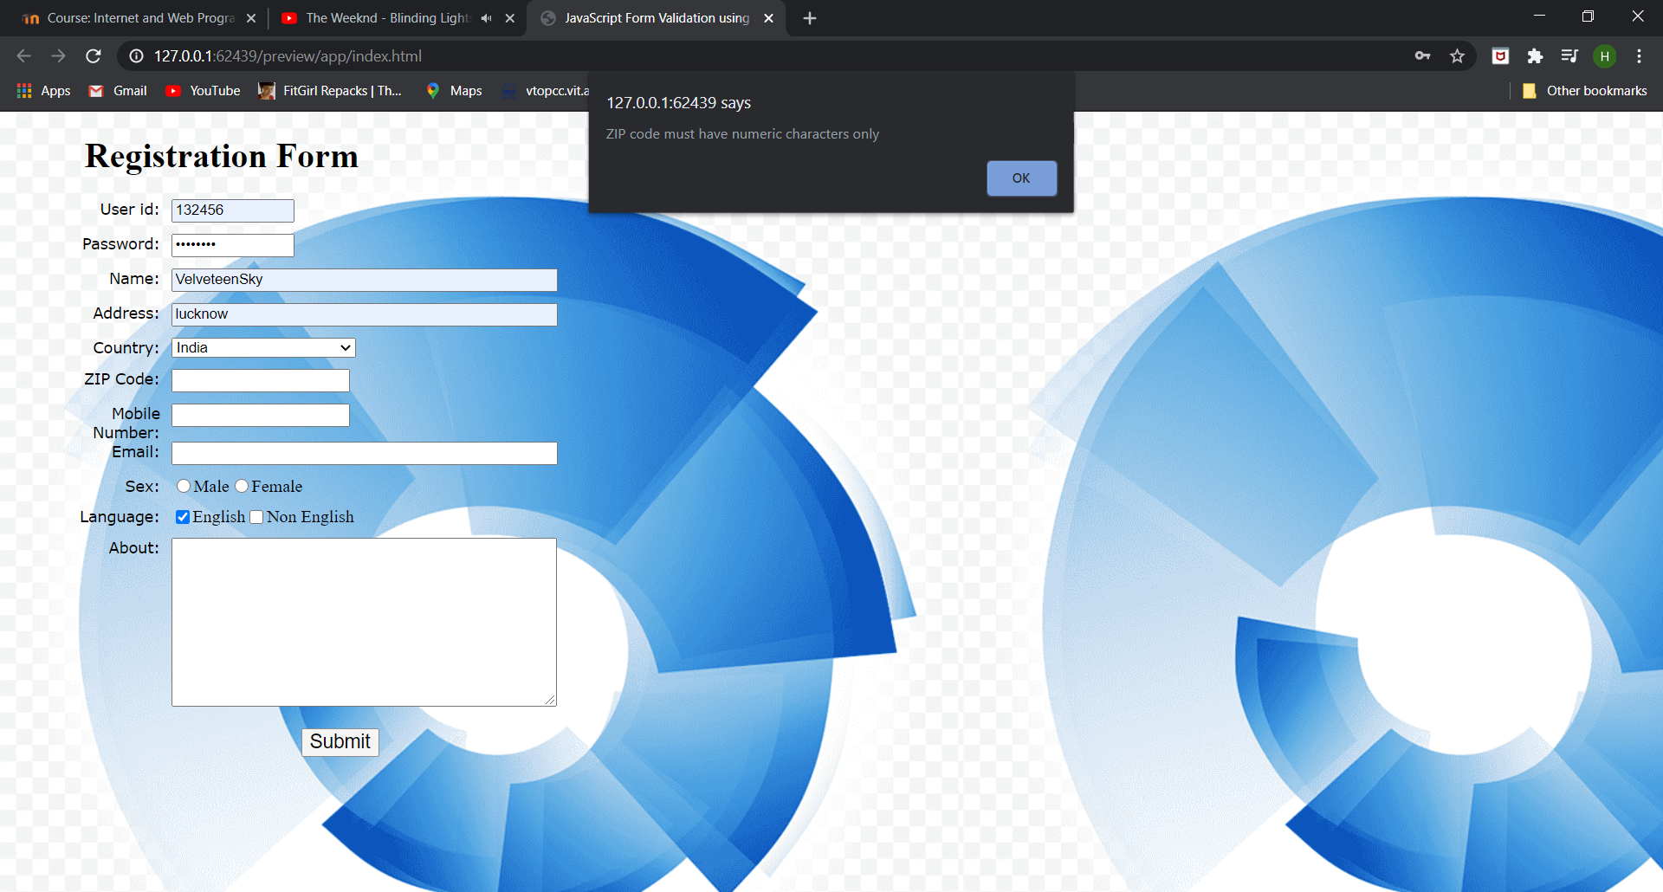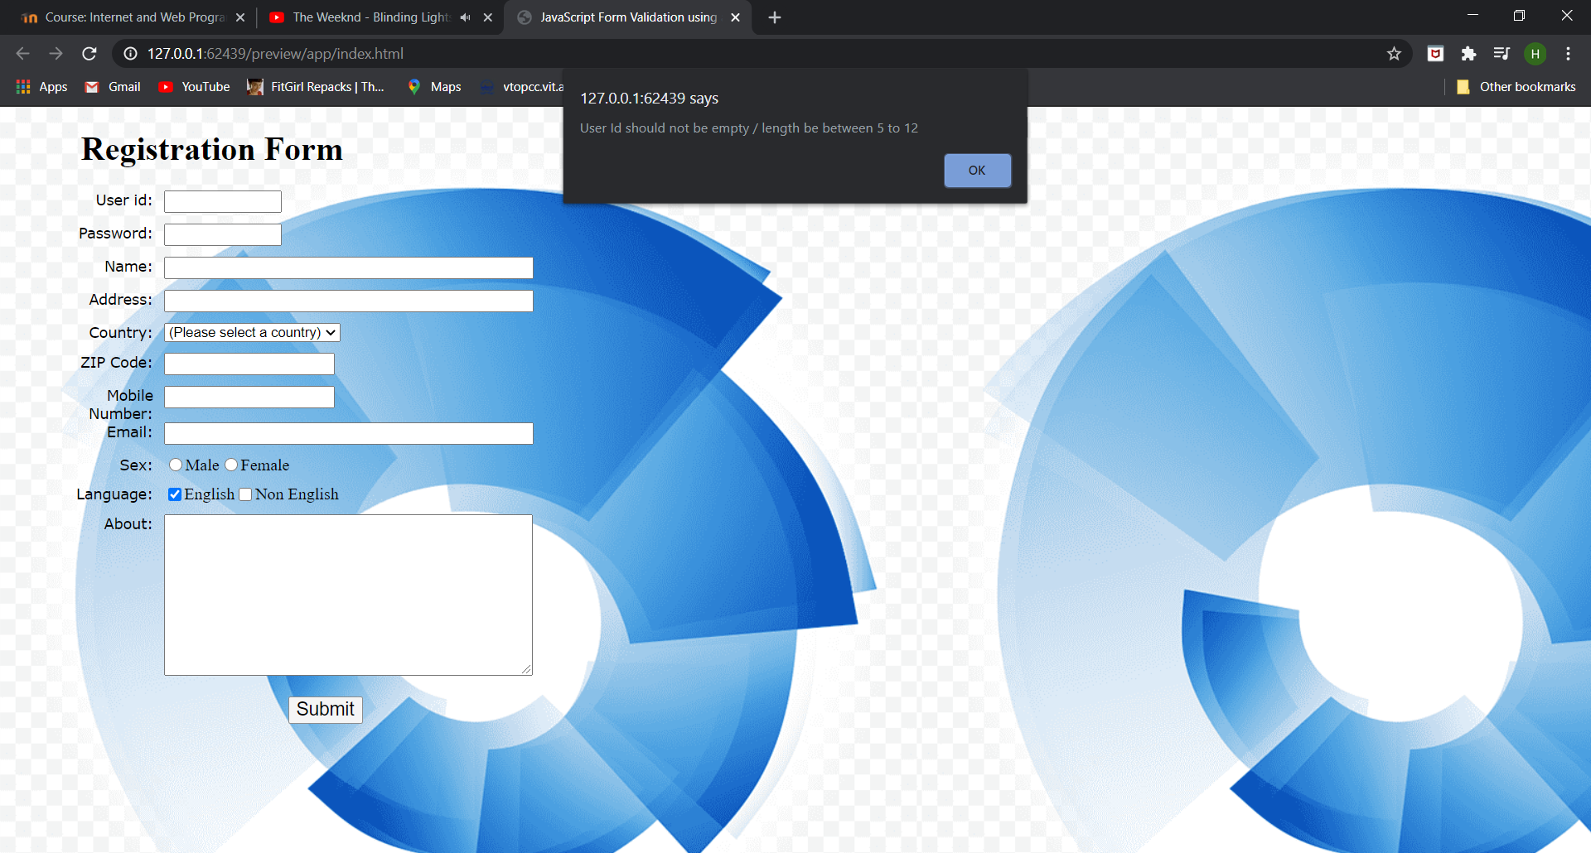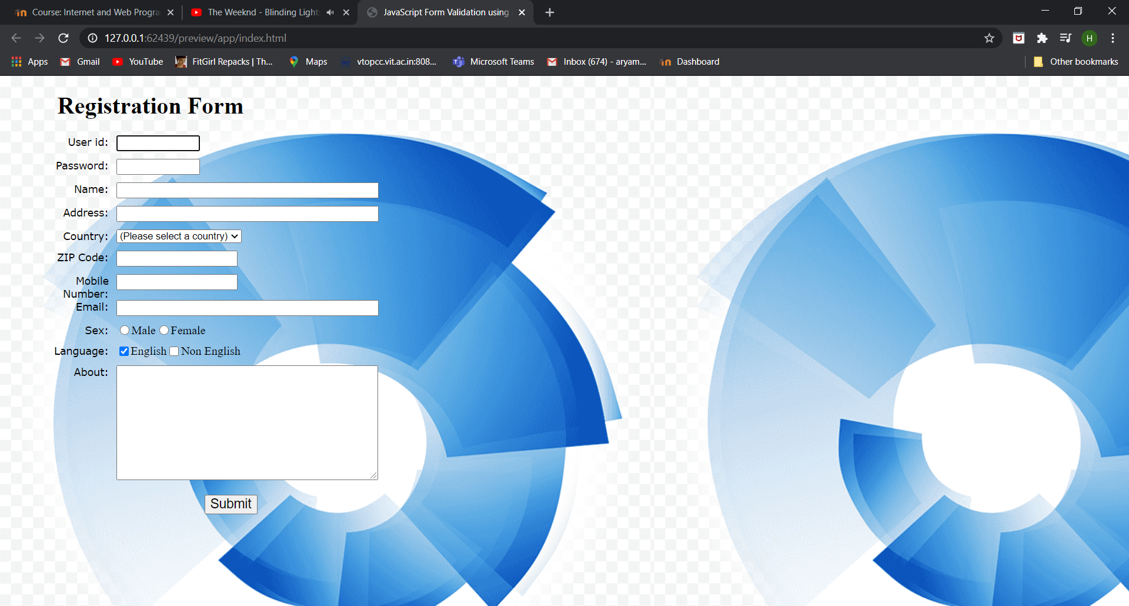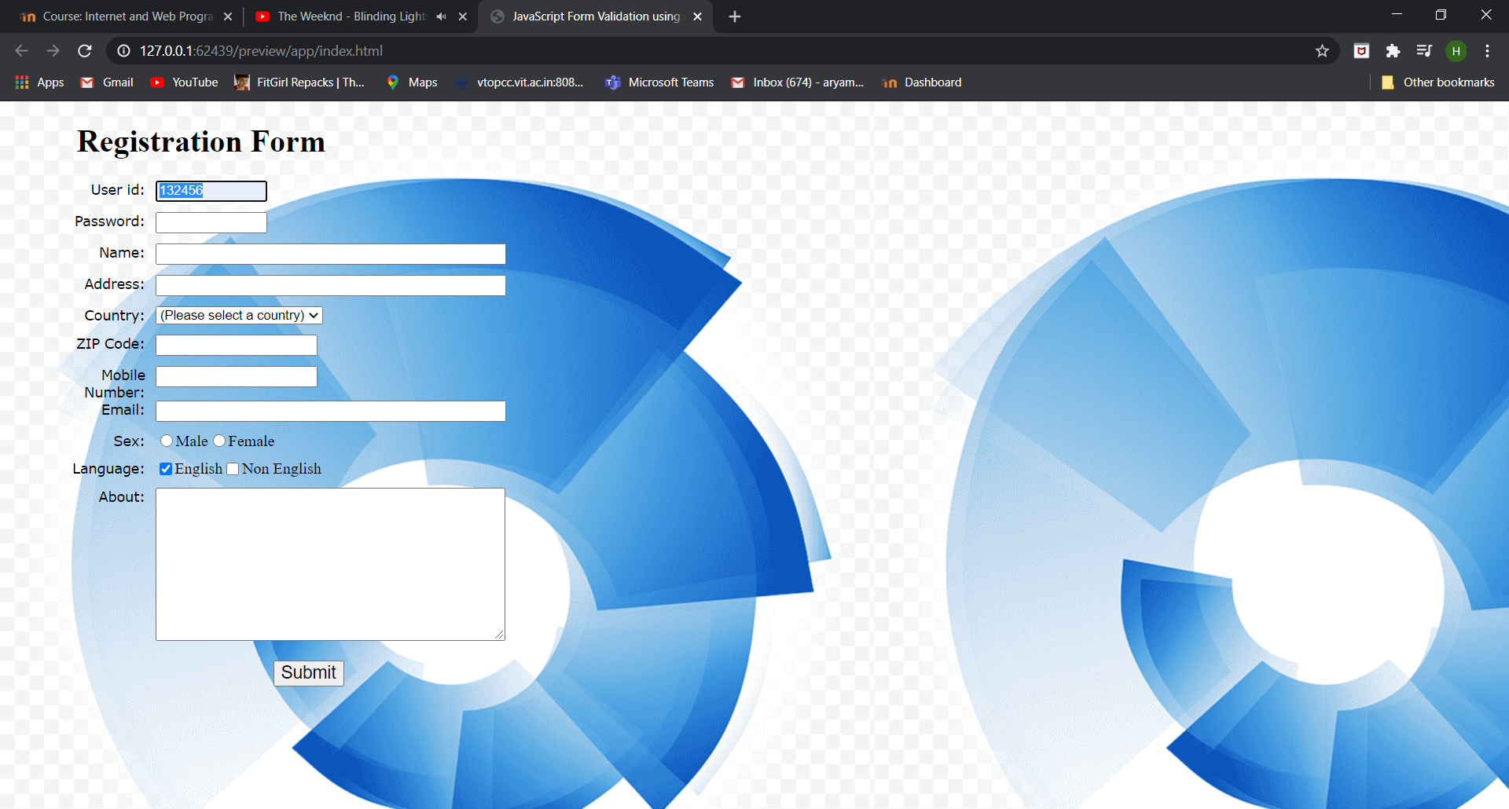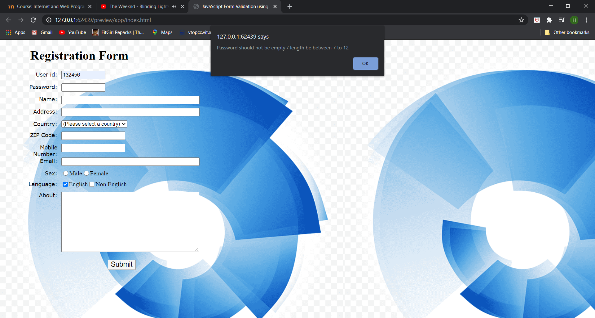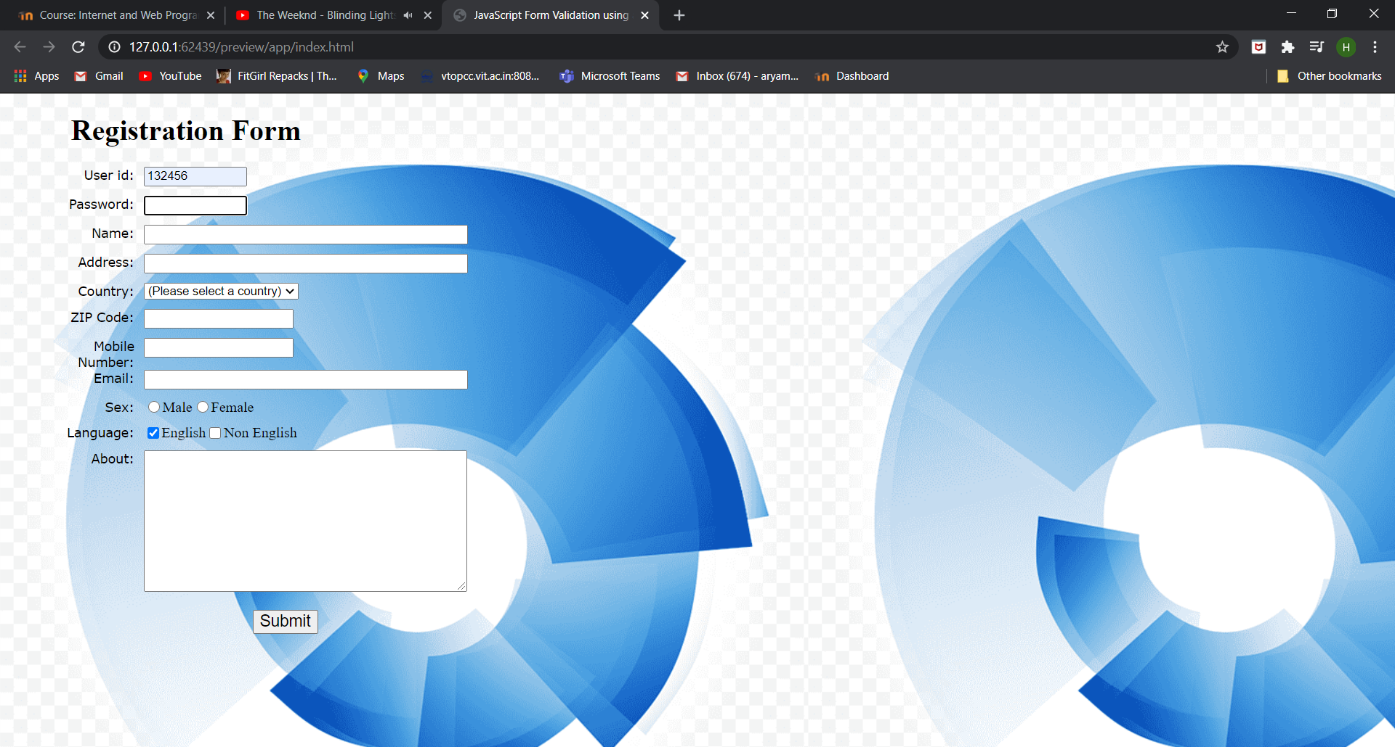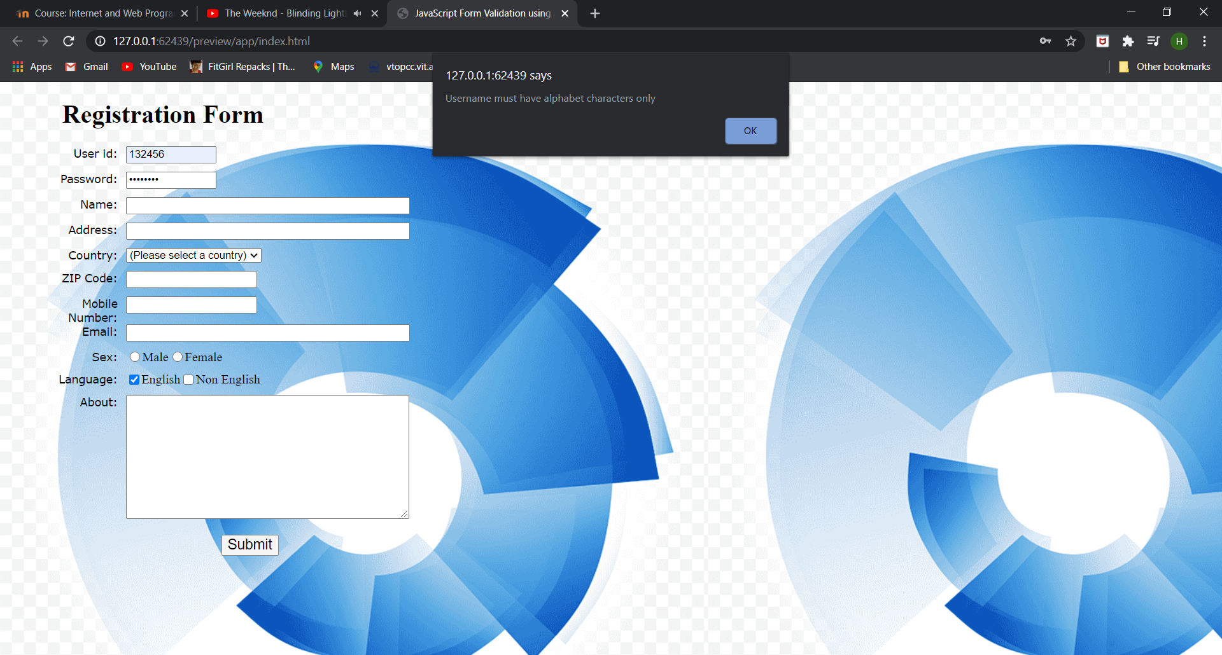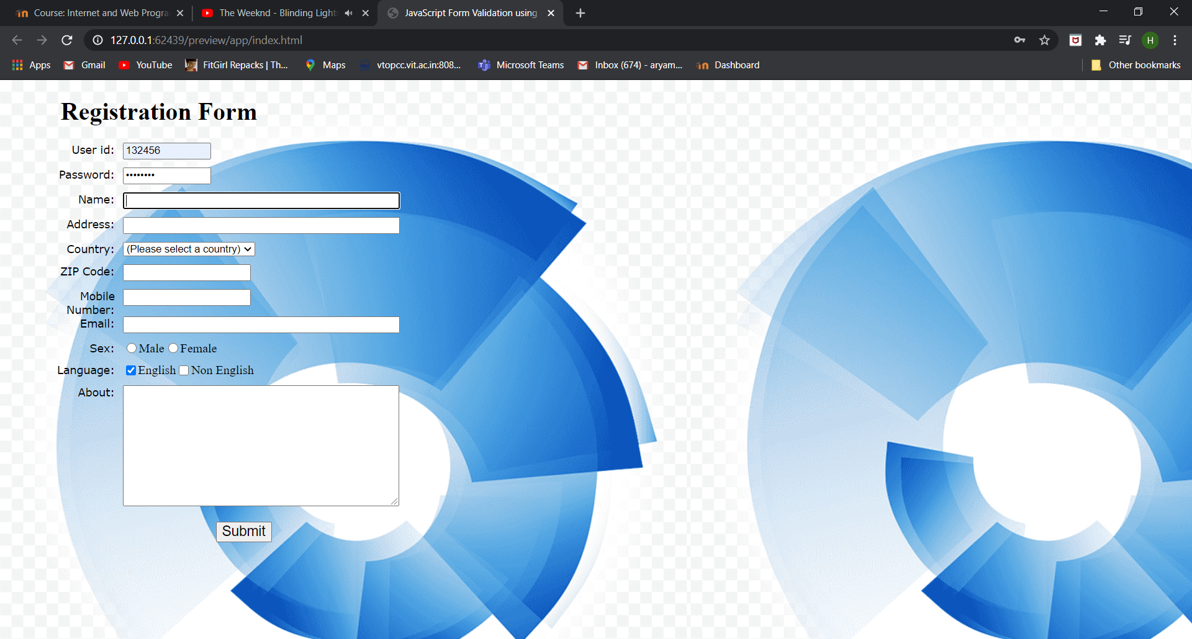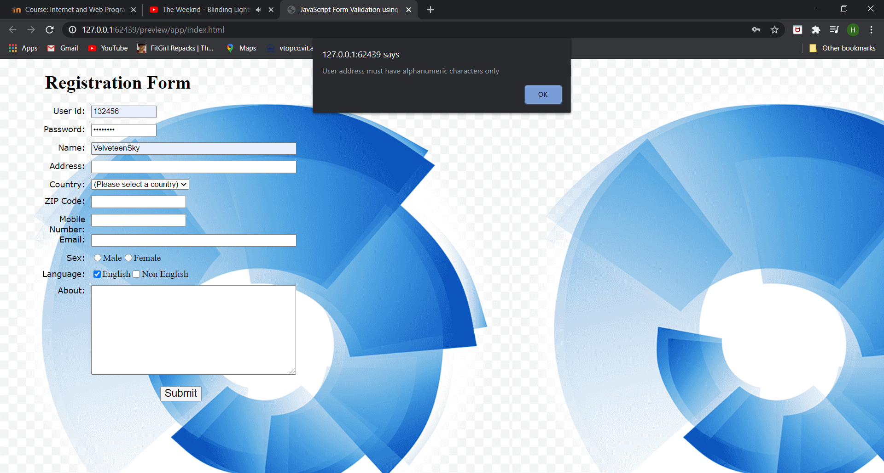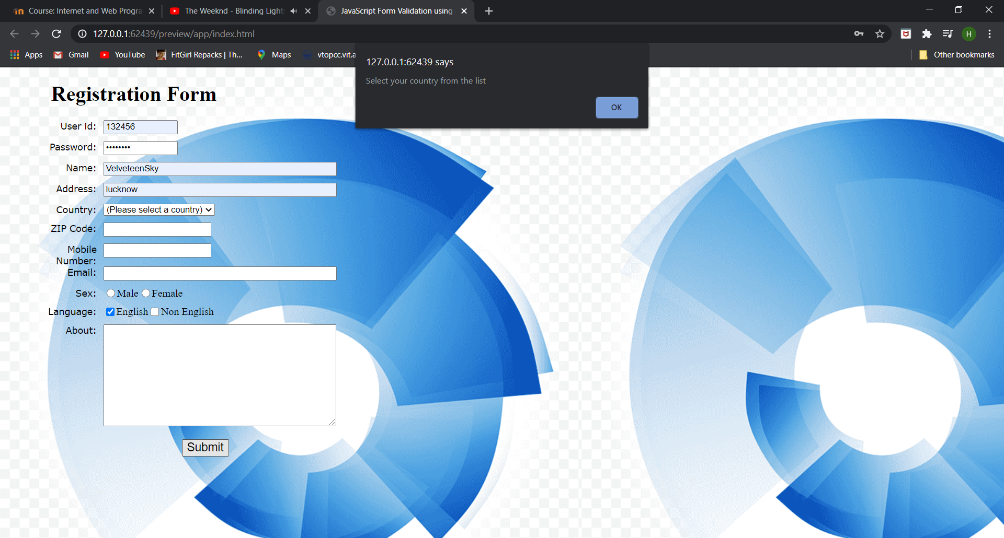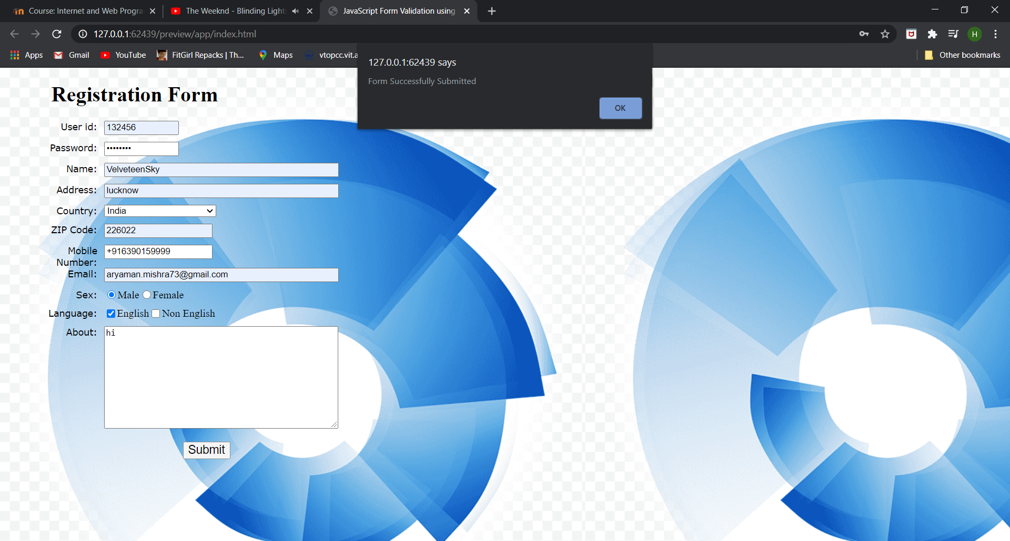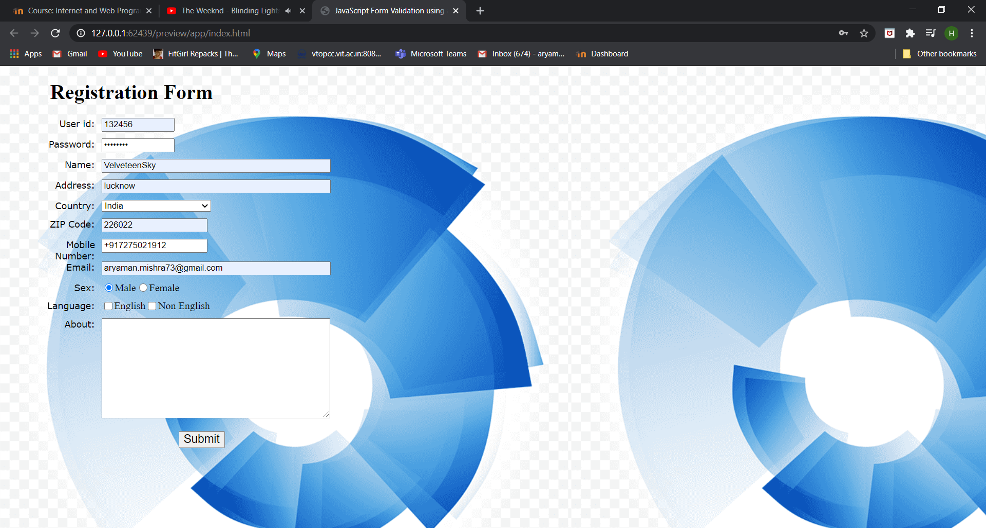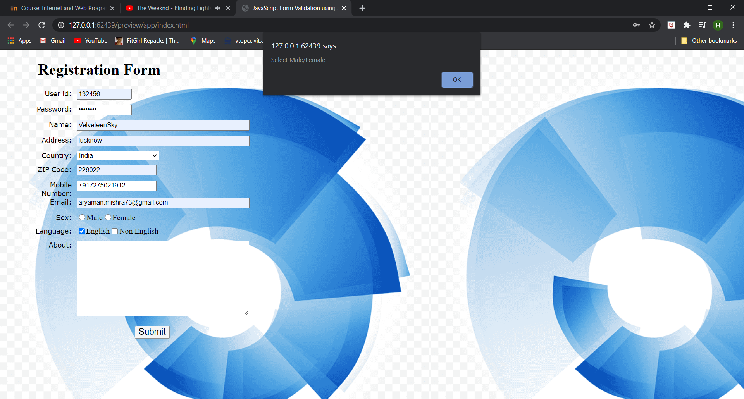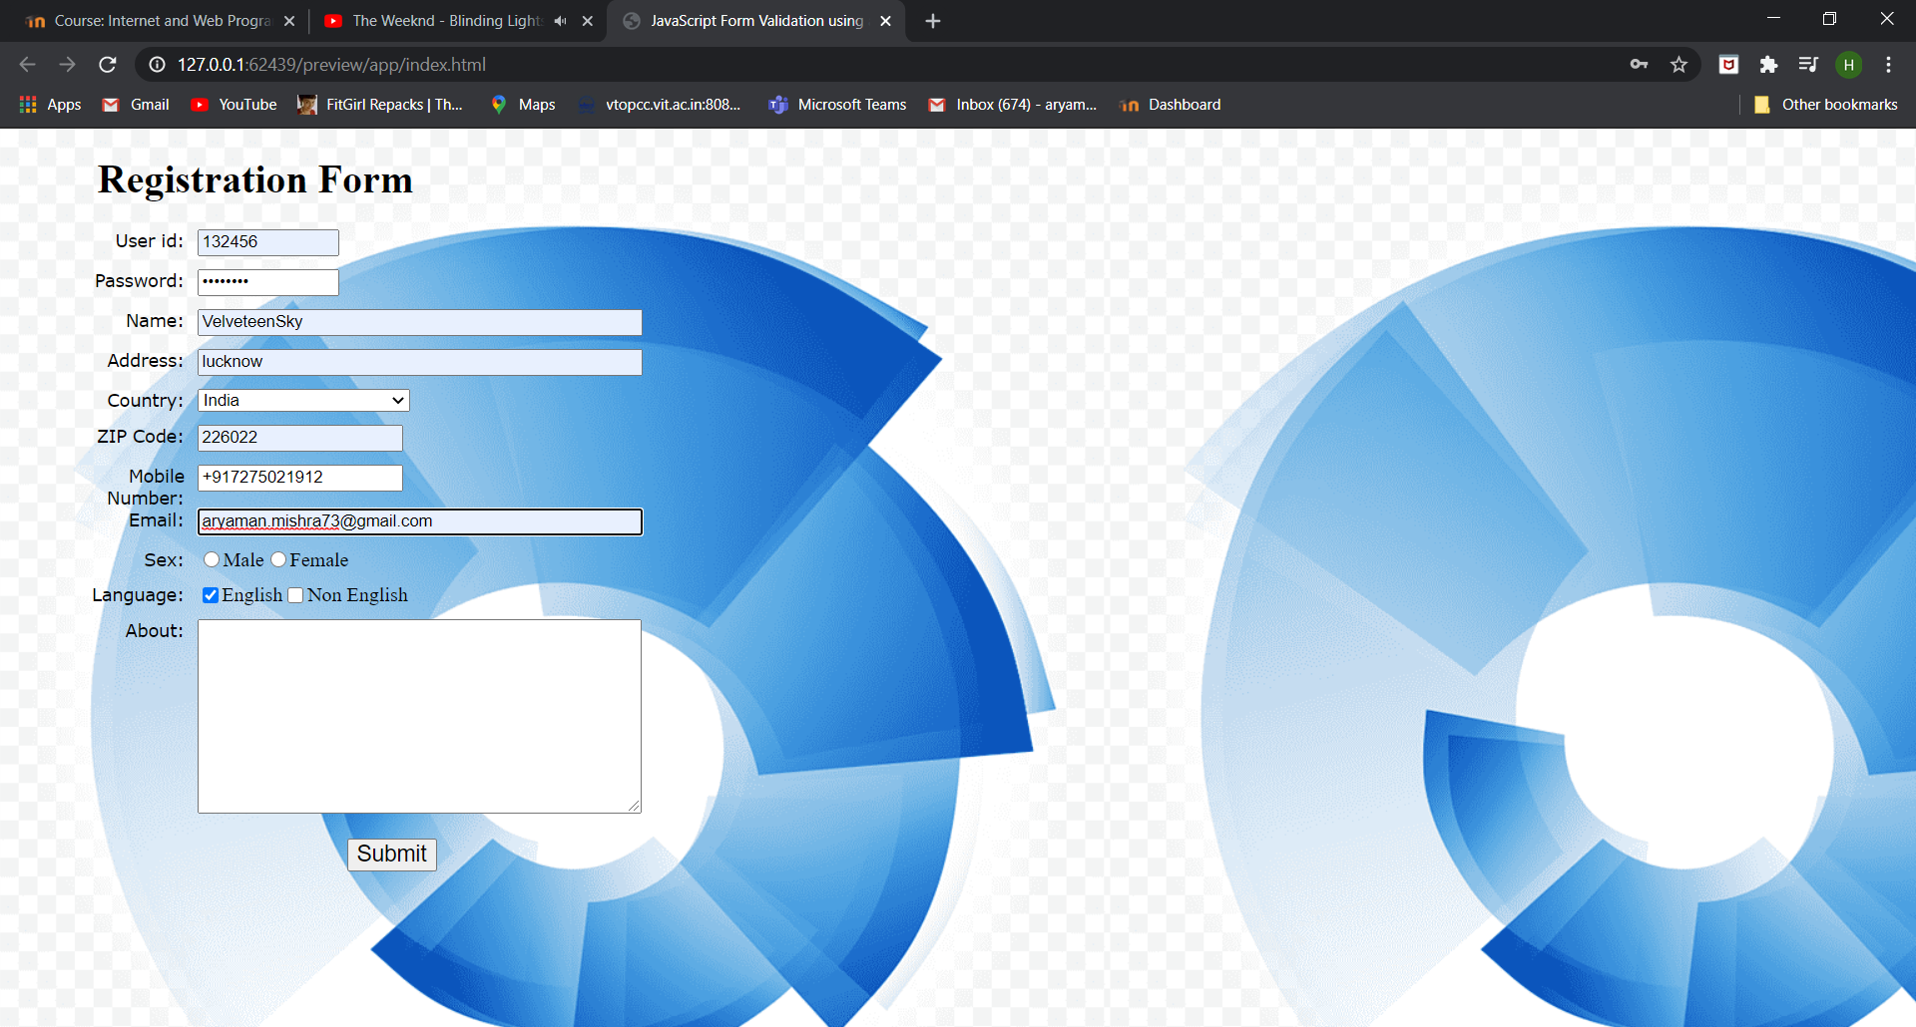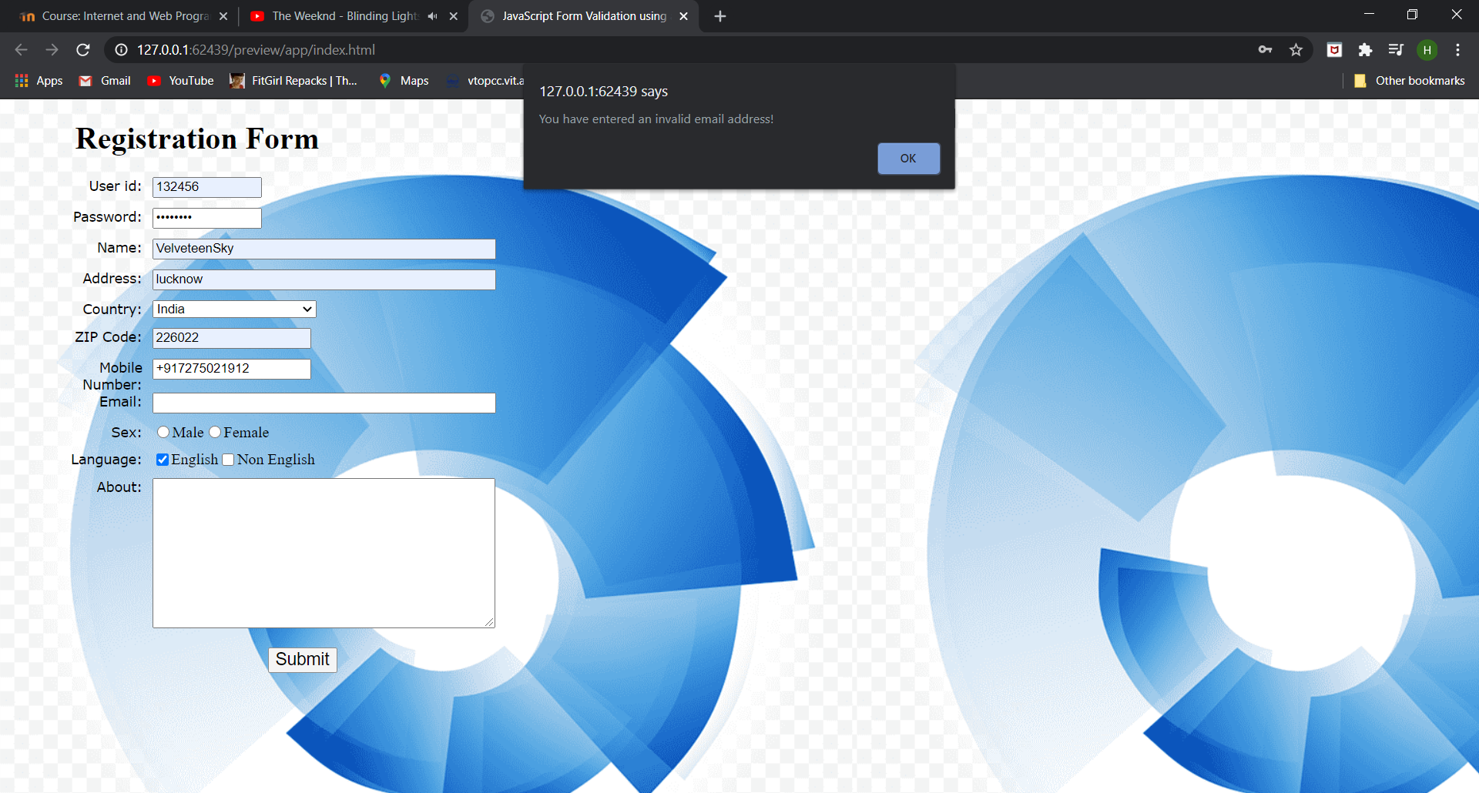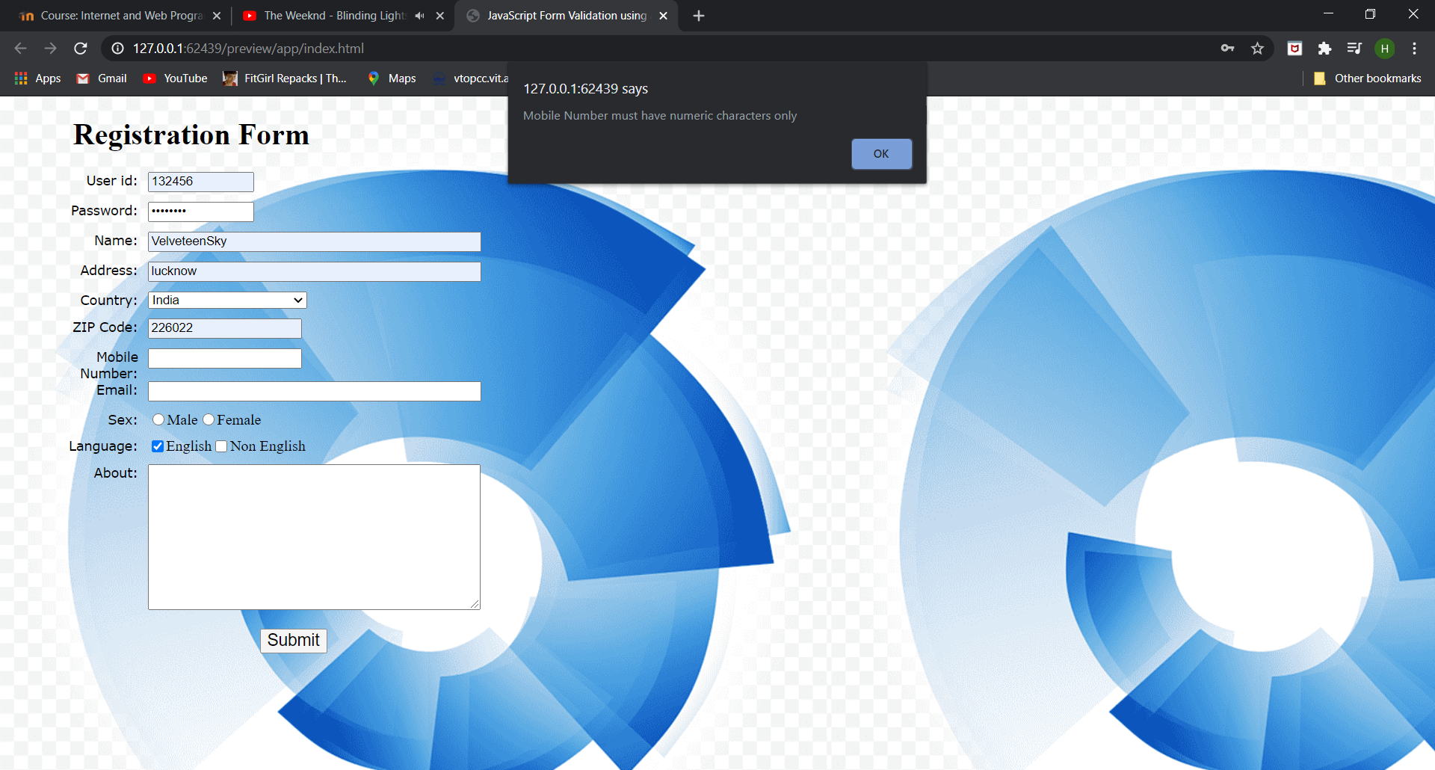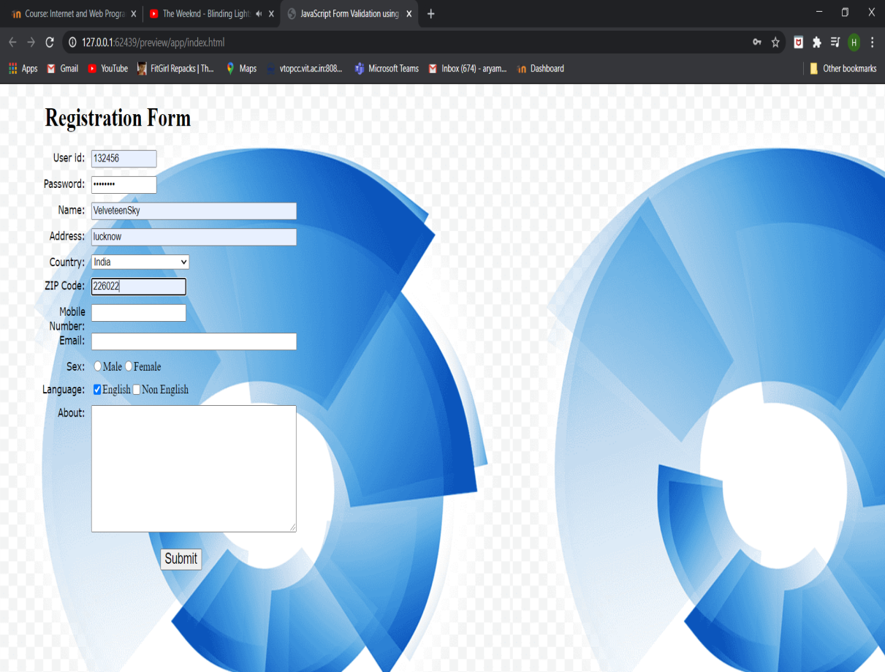

3) <!doctype html>

<html>

<head>

<meta charset="utf-8">

<title>Untitled Document</title>

<h1> a java script program to check two numbers and return true if one of the number is 200 or

if the sum of the two numbers is 200</h1>

<script>

var num1, num2;

num1 = window.prompt("Input the First integer", "0");

num2 = window.prompt("Input the second integer", "0");

a=parseInt(num1);

b=parseInt(num2);

var sum=a+b;

if(a==200 || b==200 || sum==200)

{

document.write("True");

}

else

{

document.write("False");

}

</script>

</head>

<body>

</body>

</html>

